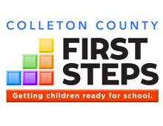
Colleton County First Steps is accepting resumes for the part time position of a Parents as Teachers Parent Educator.
Duties:
*Implement the curriculum provided by the National PAT program
*Serve children and families with a minimum of twenty four face to face contacts per year
*Coordinate services with other agencies and work with at risk families
*Complete and submit all required data and paperwork in a timely manner
*Attend all required trainings and meetings
* Must be proficient with the use of technology
*Other duties as assigned by the executive director
Qualifications:
*Bachelor’s degree in early childhood or related field of study
*Demonstrated ability to work with young children, adults, and families
Send resume to:
Attn: Cindy Riley
Colleton County First Steps
PO Box 2090
Walterboro, SC 29488
criley@colletonfirststeps.org
Qualified applicants will be contacted for an interview. No phone calls please.
This is a part time position with no benefits. Deadline to apply is January 18, 2024.

