
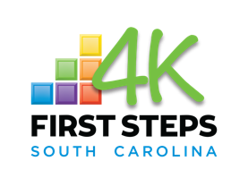

PREFERRED
QUALIFICATIONS
- Bachelor’s Degree in early childhood or related field
- CPR and First Aid Certification
- Experience working in a play-based environment
- Ability to work creatively and flexibly
HOW TO APPLY
Send a cover letter and resume to
northcharleston@kindercare.com
with the subject line:
“First Steps 4K
Lead Teacher Application”.
North Charleston KinderCare
8730 Dorchester Road
North Charleston, SC 29420
(843)552-0123
Are you interested in making a difference in the lives of young children? North Charleston KinderCare is looking for a patient and compassionate teacher who has experience working with young children. The First Steps 4K Lead Teacher will help lead developmentally-appropriate activities that encourage healthy physical, social, and emotional development for students.

RESPONSIBILITIES

- Adhere to the First Steps 4K Guidelines
- Follow all employer policies and procedures at all times
- Create and implement weekly lesson plans in accordance with the First Steps 4K approved curriculum
- Keep parents and families updated on their students’ daily activities and progress
- Communicate with families on a daily or weekly basis through writing or face-to-face.
- Foster a classroom environment of safety and respect
- Perform daily cleaning routines to keep facilities sanitary and safe
- Attend all required First Steps 4K and SC DSS trainings and obtain required continuing education hours.

BENEFITS

At North Charleston KinderCare, our mission is to develop a community of confident students who love to learn. We are passionate about creating a nurturing, caring environment where all children can thrive. We are also committed to the well-being and growth of our teaching staff. We are proud to offer regular professional development opportunities to all 123 Learning Center staff.
REQUIREMENTS
- Two-year degree in early childhood or a related field AND must be demonstrating progress towards a four-year education program
- Able to pass a Child Abuse and Neglect Registry background check
First Steps 4K Lead Teacher
1+ Years’ Experience | Full Time

