

Kids First Child
Development Center
153 Fosters Grove Rd
Chesnee, SC
(864) 510-4731
HOW TO APPLY

Send a cover letter and
resume to
cindyrollins@kidsfirst01.com
with the subject line:
“First Steps 4K
Lead Teacher Application”.
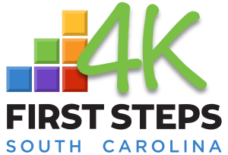
Are you interested in making a difference in the lives of young children? Kids First Child Development Center is looking for a patient and compassionate teacher who has experience working with young children. The First Steps 4K Lead Teacher will help lead developmentally-appropriate activities that encourage healthy physical, social, and emotional development for students.

RESPONSIBILITIES

- Adhere to the First Steps 4K Guidelines
- Follow all employer policies and procedures at all times
- Create and implement weekly lesson plans in accordance with the First Steps 4K approved curriculum
- Keep parents and families updated on their students’ daily activities and progress
- Communicate with families on a daily or weekly basis through writing or face-to-face.
- Foster a classroom environment of safety and respect
- Perform daily cleaning routines to keep facilities sanitary and safe
- Attend all required First Steps 4K and SC DSS trainings and obtain required continuing education hours.

BENEFITS
At Kids First Child Development Center, our mission is to develop a community of confident students who love to learn. We are passionate about creating a nurturing, caring environment where all children can thrive. We are also committed to the well-being and growth of our teaching staff. We are proud to offer regular professional development opportunities to all Kids First Child Development Center staff.
REQUIREMENTS

- Two-year degree in early childhood or a related field AND must be demonstrate progress towards a four-year education program
- Able to pass a Child Abuse and Neglect Registry background check
- Ability to use a variety of computer applications to complete tasks

PREFERRED
QUALIFICATIONS

- Bachelor’s Degree in early childhood or related field
- CPR and First Aid Certification
- Experience working in a play-based environment
- Ability to work creatively and flexibly
First Steps 4K Lead Teacher
1+ Years’ Experience | Full Time

