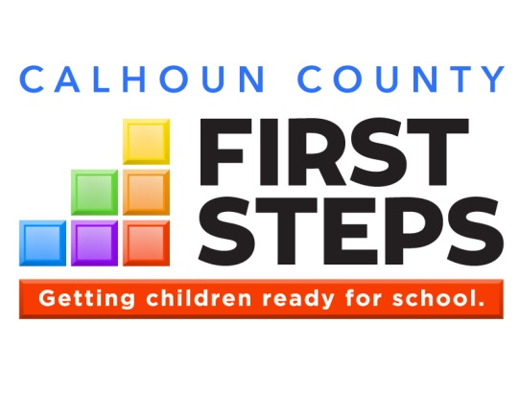

CALHOUN COUNTY FIRST STEPS: Employment Opportunity

Calhoun County First Steps is currently accepting resumes for the following position:

Parent Educator: Must be knowledgeable about what promotes optimal parent-child interaction and early childhood development. A degree in early childhood education is preferred with experience working with families with children birth to 4 years. Applicants must possess outstanding oral and written communication skills and have a valid S.C. Driver’s License. Salary range $28,000-30,000 a year.

Interested applicants must submit a resume to Calhoun County First Steps, PO Box 195, St. Matthews, SC 29135 or cc1steps@calhounfirststeps.org. By December 21, 2023. For additional information contact Calhoun First Steps at 803-655-5126.

